Everything starts with __init__. The main program is intercepting, and the key function for calculating the interception direction is intercept_solving, which involves vector calculations—just check ChatGPT for explaination.
Some important concepts are defined as：
Distance between
Ball and intercept point
Intercept distance
Intercept angle
Angle to ball
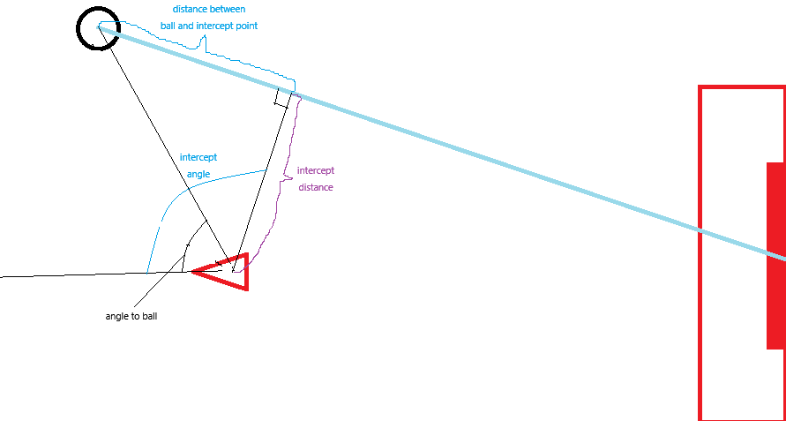
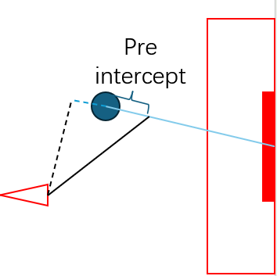
When the ball goes too deep, a fix intercept point will be created as shown above
The Defender has the following stages:
- INITIAL
- INTERCEPT
- ADJUSTING_ANGLE
- APPROCH
- SIDE_STEP_ADJUST
- SIDE_STEP
- FINISH
- END

Stage Descriptions:
- INITIAL
This is copied from the goalkeeper. Once completed, it moves to the INTERCEPT stage.
- INTERCEPT
This stage does not execute any physical actions; it only determines which stage to enter next:
  - If the robot is very close to the intercept point, it directly enters SIDE_STEP.
  - If the absolute value of the intercept angle exceeds 15 degrees, it enters ADJUSTING_ANGLE.
  - Otherwise, since it is already facing the intercept point, it proceeds directly to APPROACH.
- ADJUSTING_ANGLE
This stage rotates NAO toward the intercept point.
  - The robot rotates based on the intercept angle, with a tolerance of ±20 degrees.
  - If the intercept angle becomes less than 21 degrees, it moves to APPROACH.
- APPROACH
The robot walks toward the intercept point.
  - If the distance to the intercept point is greater than a threshold, it continuously monitors and corrects its direction based on the intercept angle while moving forward.
  - If the angle deviation becomes too large, it transitions back to ADJUSTING_ANGLE.
  - To prevent excessive directional corrections when the robot is very close to the intercept point, if the distance is within a second threshold range, it only checks the distance to determine if it has arrived.
  - Once it reaches the intercept position, it transitions to SIDE_STEP_ADJUST.
- SIDE_STEP_ADJUST
This stage makes NAO face the ball.
  - If the intercept point becomes too far, meaning the side step would take too long, it returns to INTERCEPT.
  - The robot rotates based on the angle to ball with a 25-degree tolerance (a smaller tolerance may cause it to get stuck continuously turning left and right).
  - When the angle difference is within 25 degrees, it sets a rotation flag isStepRight for the next step and moves to SIDE_STEP.
- SIDE_STEP
The robot moves sideways to block the ball’s path. Since the APPROACH stage typically brings it directly to the intercept point, side-stepping is used less frequently.
  - To prevent rapid switching of movement directions due to small position errors (which could cause the robot to fall), a hysteresis comparator (not sure if this is the correct name) is implemented.
  - The robot constantly checks:
    - If the intercept point is too far, it returns to INTERCEPT.
    - If it is not facing the ball, it returns to SIDE_STEP_ADJUST.
  - If isStepRight is None, it checks whether the robot is already at the intercept point (if distance is within the threshold).
    - If distance is small enough, it moves to FINISH.
    - If distance is too large, it determines the direction (left or right) based on the intercept angle and updates isStepRight accordingly.
  - Based on isStepRight, the robot enters the left or right side step condition.
    - While stepping, it checks whether it has crossed the goal-to-ball line using the intercept angle.
    - If it has not crossed, it keeps stepping.
    - If it has crossed, it further checks the intercept distance:
      - If the distance is within the threshold, it moves to FINISH.
      - If the distance is too large, it toggles isStepRight to switch stepping direction.
- FINISH
  - The robot checks whether it is stable. If stable, it transitions to END.
  - If not stable, it waits until the action is completed.
  - It continuously monitors distance, and if it exceeds the threshold, it returns to INTERCEPT.
- END
  - The robot stops moving.
  - It continuously monitors distance, and if it exceeds the threshold, it returns to INTERCEPT.

